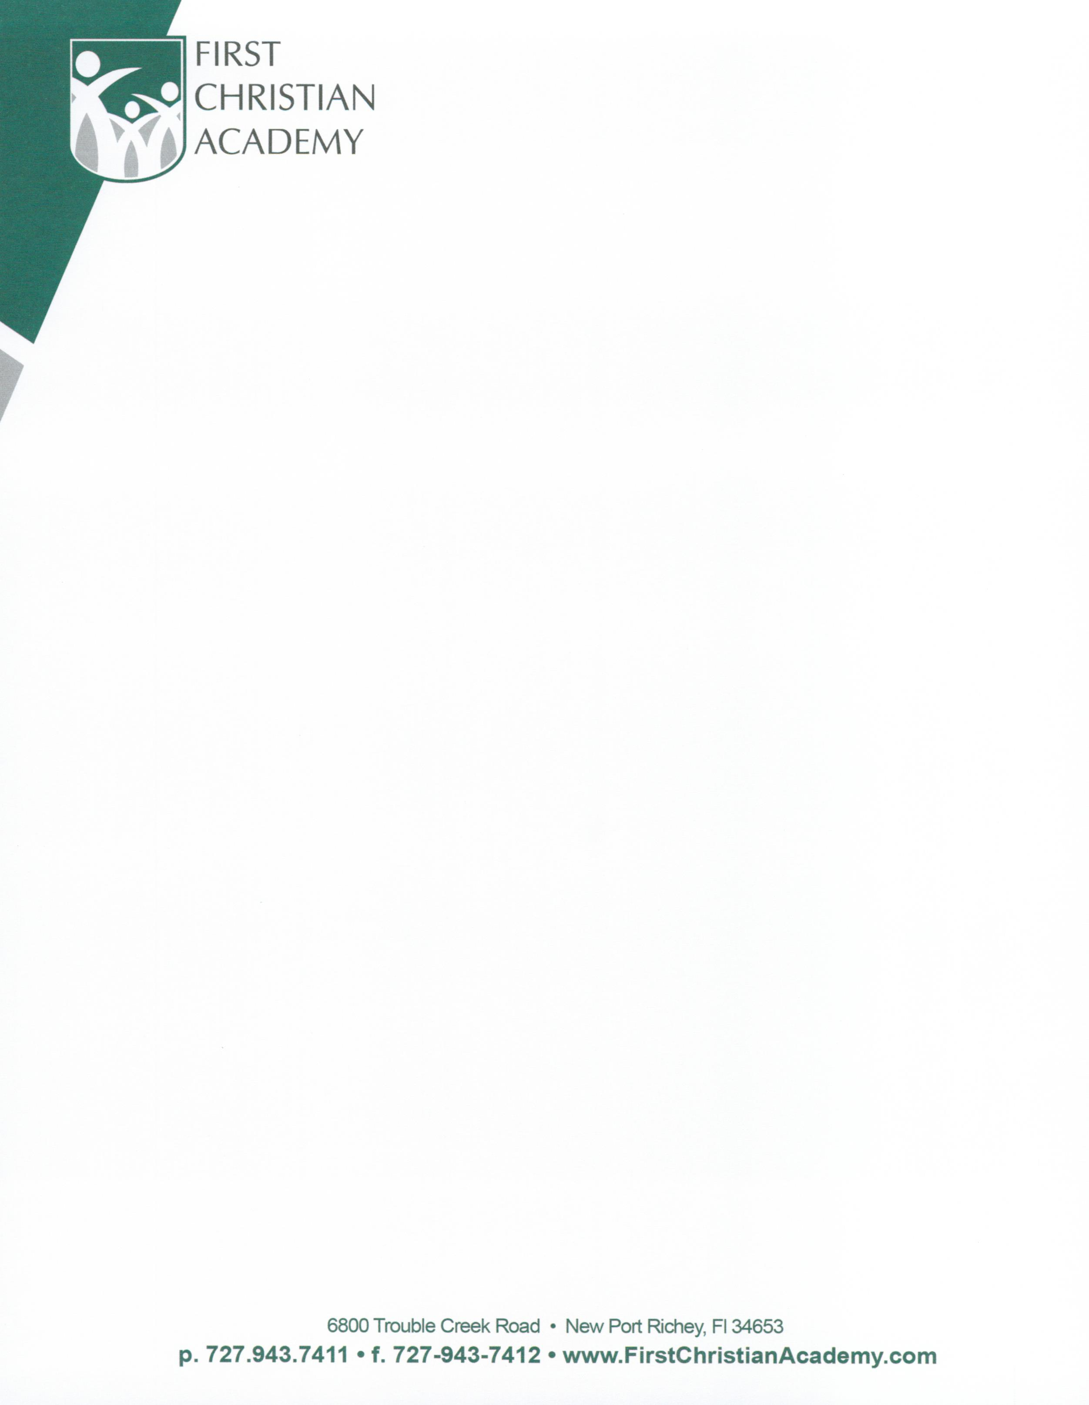
INFANT/TODDLER PROGRAM FEES
Registration Fee for Infant & Toddlers: $225 (if paid in February), $250 (if paid in March), $300 (if paid in April or after)

*Fee is NON-REFUNDABLE*

TWO & THREE YEAR OLD CLASS:
5 full days 8:45-3:00: $560/month
5 half days 8:45-12:30: $480/month
3 full days 8:45-3:00: $380/month
3 half days 8:45-12:30: $300/month

3 DAY VPK 8:45-2:00 (must be 4 by 9/1/2013):
Wrap Care 2:00-3:00: $150/month

5 DAY VPK 8:45-12:30 (must be 4 by 9/1/2013):
Wrap Care 12:30-3:00: $300/month

**DROP OFF TIME FOR ALL PROGRAMS BEGINS AT 8:30**

PAYMENT: Tuition is due on the first of each month. Tuition is not pro-rated for holidays or absences.

MULTIPLE CHILD DISCOUNTS: 1st (oldest child) full price, 10% discount for 2nd sibling, 15% discount for 3rd sibling

MEALS: A morning snack is provided by the school, we ask that the student bring his/her own drink. Parents are responsible for providing lunch.

INFANT CLASS (must be 6 weeks by 8/1/2022) &
TODDLER CLASS (must be 1 by 9/1/2022):
5 full days 8:15-2:30: $780/month
5 half days 8:15-12:00: $700/month
3 full days 8:15-2:30: $600/month
3 half days 8:15-12:00: $540/month
2 full days 8:15-2:30: $540/month
2 half days 8:15-12:00: $460/month

**DROP OFF TIME FOR ALL PROGRAMS BEGINS AT 8:15**

PAYMENT: Tuition is due on the first of each month. It is calculated on an annual basis and is divided into 10 equal payments (8/1/2022-5/1/2023). A Late Fee of $30 will be charged if payment is not received by the 5th of the month. Tuition will not be refunded for absences due to illness, holidays, vacations, or withdrawals.

MULTIPLE CHILD DISCOUNTS: 1st (oldest) child pays full price, 10% discount for 2nd sibling, 15% discount for 3rd sibling. *Please see financial office for Pastor, Military, and First Responder discounts.

MEALS: Parents are responsible for providing all milk, formula, snacks, and food. All bottles and baby food jars and containers must be individually labeled with each child’s first and last name.

REFERRALS: $100 gift card for each new family referred to FCA, after they have completed one quarter. This must be noted on the new family’s application prior to the first day of school.

2022-2023

TWO & THREE YEAR OLD CLASS:
5 full days 8:45-3:00: $560/month
5 half days 8:45-12:30: $480/month
3 full days 8:45-3:00: $380/month
3 half days 8:45-12:30: $300/month

3 DAY VPK 8:45-2:00 (must be 4 by 9/1/2013):
Wrap Care 2:00-3:00: $150/month

5 DAY VPK 8:45-12:30 (must be 4 by 9/1/2013):
Wrap Care 12:30-3:00: $300/month

**DROP OFF TIME FOR ALL PROGRAMS BEGINS AT 8:30**

PAYMENT: Tuition is due on the first of each month. Tuition is not pro-rated for holidays or absences.

MULTIPLE CHILD DISCOUNTS: 1st (oldest child) full price, 10% discount for 2nd sibling, 15% discount for 3rd sibling

MEALS: A morning snack is provided by the school, we ask that the student bring his/her own drink. Parents are responsible for providing lunch.

THREE YEAR OLD CLASS:
5 full days 8:45-3:00: $560/month
5 half days 8:45-12:30: $480/month
3 full days 8:45-3:00: $380/month
3 half days 8:45-12:30: $300/month

